Python Analytics Report

ECO 32500-ONL (Fall, 2023)

Instructor: John Droescher

Steven Chu

Edwin Aguilar

Python Analytics Report

I am your Regional Director and have presented you with the following question:

*I am looking to improve this year’s performance. What suggestions do you have for success?*

In order to answer this question we must reframe it to be more specific and overall a more approachable question to answer. How can we use this year's performance to give detailed opportunities to increase the three pillars that define “success”. There are three indications of success, profit, longevity, and quality. With that being said, we bring forth a proposal that showcases opportunities suggested by the data found within the data provided.

Given the scale of sales and production of the company. The dataset under consideration exhibits a substantial volume of information, rendering it formidable in scale. Therefore the data poses a significant challenge to the process of interruption and needs a comprehensive cleaning procedure. The extensive nature of the dataset demands a conscientious approach to ensure the reliability and validity of the subsequent analysis.

This company has its top 5 highest profiting regions in Central America, Western Europe, South America, Oceania, Northern Europe.

* Prioritize items such as, Cleats, Shop By Sport, Water Sports, Cardio Equipment, Mens Footwear. These items are the top five most profiting items. But the distribution limited their potential profit.
* Example: The data shows electronics makes up 9.3%, however it's 7th place for highest profiting categories. Whereas Cleats makeup 1.7% but it generated the highest profit by ~.8 from 2nd place. Reevaluate the distribution of items and prioritize higher profit items.

**Figure 1.** Chart comparison between the production of goods and the highest profiting categories.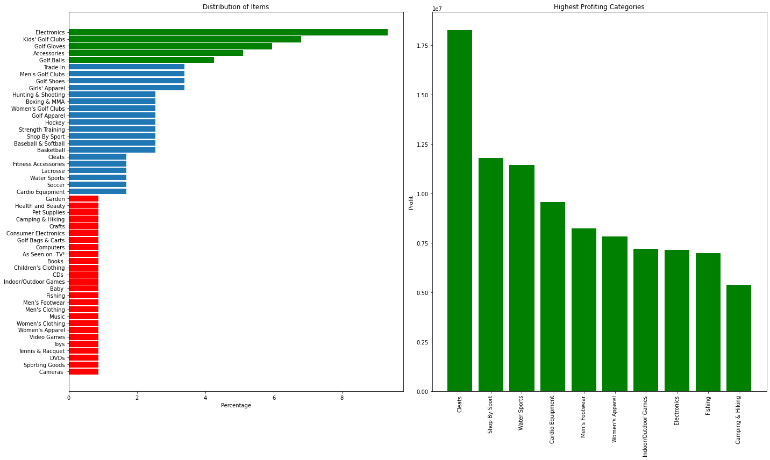

One of the keys to success is having consistent on-time deliveries. However, the data shows that there is an abnormal amount of Late Deliveries (Europe peaked at ~10,000 late deliveries) while if we compare that to on-time, it's only about ~4,000. The distribution between those who have first, second, and standard class deliveries is expected where people usually don’t pay for expedited shipping unless they have a different circumstance. With that being said

The following opportunities are presented after analysis :

Decrease the amount of late deliveries and increase the amount of on-time deliveries as this would increase the customer retention. This would show business reliability. Whether people receive their order in time or not makes a difference in customer satisfaction. The more pleased and smooth an order goes, the more likely that customer will return.

**Figure 2.** Visualization of the deliveries between the different classes to showcase the count difference between them.

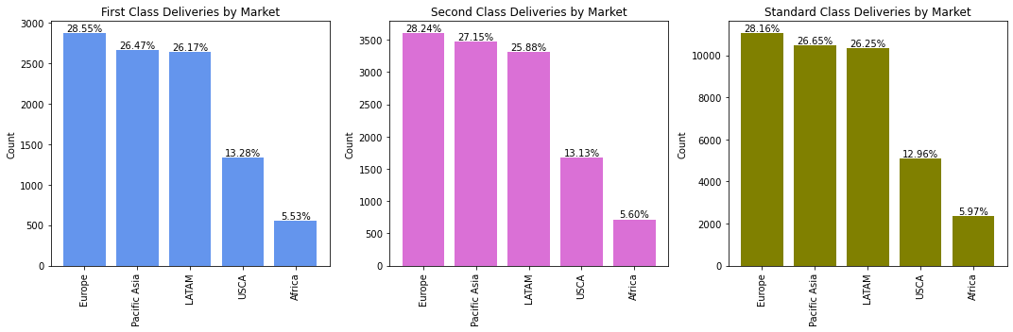

To reduce costs, remove stores that aren't producing enough profit to justify the cost. Setting quotas that requires certain regions to break even so that less money is being lost. If quotas are not being met, removing stores would help with cost management as the stores located in areas are no longer bringing in negative profit.

The graphs below show that in the regions of Africa and Asia there is a very small number of sales compared to the other regions. This is because there are very few stores located in regions such as Asia, thus leading to a lower aggregate profit percentage compared to the others. Additionally, because regions like Africa are third world countries, the economy is not as successful as the regions within the United States. Thus, removing the stores from those regions should be taken into consideration if they are barely or not even breaking even. Another possible issue is marketing. Using the geographical locations of the store concentrations on the world map, the stores are heavily centralized within the United States. This suggests that the company is well known and advertised in the States but perhaps not in the other regions that they are located in.

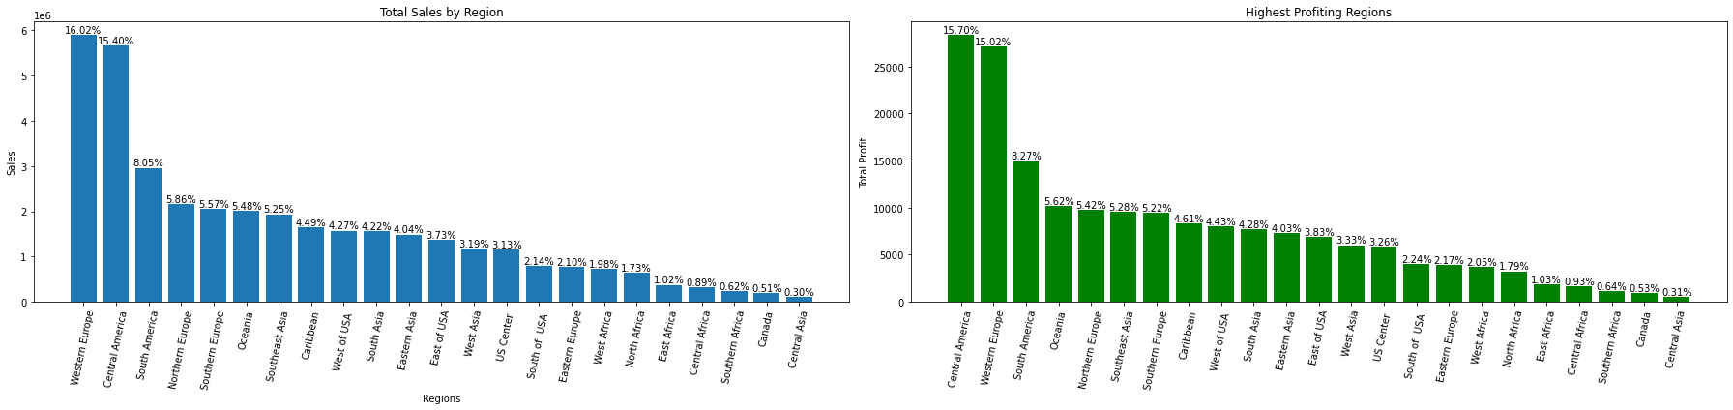

**Figure 3.** Chart comparison to showcase the relationship between ‘Total Sales By Region’ and ‘Highest Profiting Regions’

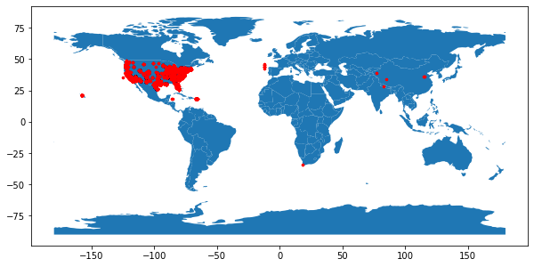

**Figure 4.** Map created using library ‘geopandas’ to visualize the geographical locations of the stores using the provided data of longitude and latitude.

**Figure 5.** Bar graph to show the types of consumers that are making purchases with the consumers.

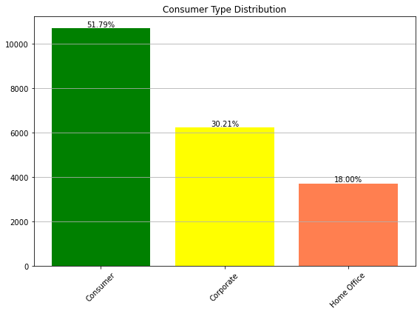

This shows the customer type distribution. Individual consumers make up 51.79% of the distribution. Focusing on the individual customer experience is important to keeping those consumers coming back. The consumer type distribution shows that regular consumers represent over half the sales being made. Corporate consumers being ~30.21% and Home Office consumers being ~18%. Relating back to the company audience, this suggests that regular consumers were making purchases for recreational purposes. However, the recreational purposes are not suited/properly advertised for other regions such as Asia. Improving the marketing of the company for other regions would help increase the profit distribution for other regions that are lower on the scale. Hiring people within the social media related field to use apps such as Douyin, Instagram, TikTok would help with marketing.

**Figure 5.** Three different graphs to show the ratio of deliveries sorted by on-time, late, and canceled.

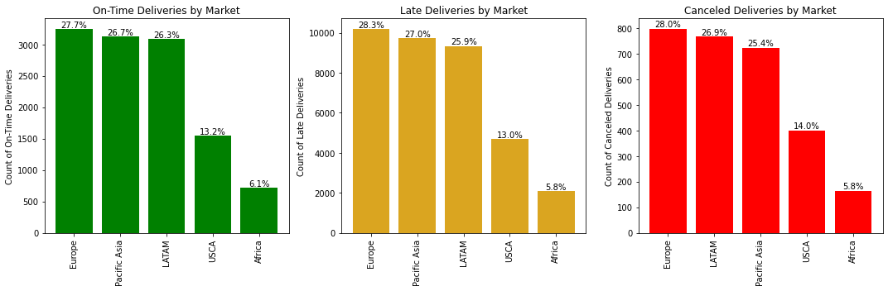

The total amount of First and Second class deliveries to Standard Class is lower. Offering deals such as student discounts, trials, could help with customer retention. Offering deals such as student discounts, trials, could help incentivize people to use expedited shipping and improve customer retention as it shows that the company often provides offers. Offering deals keeps customers engaged.

To reiterate, we are given the question “*I am looking to improve this year’s performance. What suggestions do you have for success?*” The reframed question, “How can we use this year's performance to give detailed opportunities to increase the three pillars that define “success”.” There are three indications of success, Profit, Longevity, and Quality.

**Figure 6.** Two trend lines to show the relationship between costs and sales. Data suggests that the company shut down and stopped all productions.

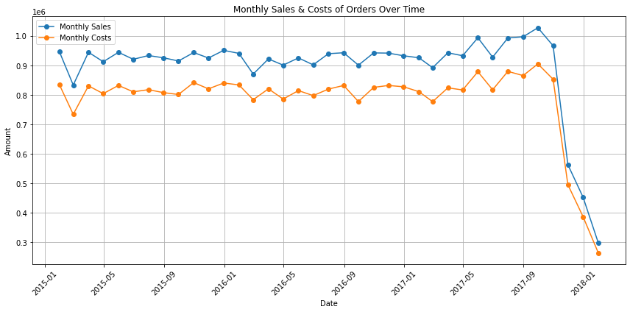

As shown in this graph, we can see that company sales plummeted within 3 years. The data provided to the analytics team has suggested a couple opportunities to uplift the company once again.

* Focus on producing items in categories such as, Cleats, Shop By Sport, Water Sports, Cardio Equipment, Mens Footwear. These categories are the top five most profiting items. But the distribution limited their potential profit. Categories high in production but low in profit will need to be reconsidered on the quantity they are produced.
* Improve the amount of on-time deliveries relative to late deliveries as this would help with customer retention. This would show business reliability. Whether people receive their order in time or not makes a difference in customer satisfaction. The more pleased and smooth an order goes, the more likely that customer will return.
* To reduce costs, remove stores that aren't producing enough profit to justify the cost. Setting quotas that requires certain regions to break even so that less money is being lost. If quotas are not being met, removing stores would help with cost management as the stores located in areas are no longer bringing in negative profit.
* The consumer type distribution shows that regular consumers represent over half the sales being made. Corporate consumers being ~30.21% and Home Office consumers being ~18%. Relating back to the company audience, this suggests that regular consumers were making purchases for recreational purposes. Improving the marketing of the company for other regions would help increase the profit distribution for other regions that are lower on the scale. Hiring people within the social media related field to manage company accounts on media such as Douyin would help with marketing towards other regions. (Mainly Asia since Douyin is heavily used in China).

Thank You,

Steven Chu, Edwin Aguilar Romero